What to do with your Insulin pump if you have medical tests
Pumps and Medical Tests
Your insulin pump should not be exposed to x-rays, radiation and strong magnetic fields. The very strong magnets in MRI can interfere with the motor in your pump and change how much insulin you receive. If you use a metal (stainless steel) inner cannula, it should also not be exposed to strong magnets from MRI. Soft cannulas are not a problem.

What do I do if I have a medical test?
All insulin pump companies recommend that you disconnect or take your pump off for many tests where there is a risk of exposure to x-rays, radiation or MRI. You will have to leave your pump outside the room where the test is done. Check with your healthcare provider on removal guidelines.

***If you have a “permanent” pump, like Omnipod or Dexacom, for example, it is best to schedule the test on the day that your insulin pump is to be changed.***

Do I have to adjust my insulin for the test?
Use the advice given by your diabetes educator or doctor for disconnecting your pump. In general, if your pump is disconnected for less than 1 hour, you do not need to make any changes. If you will be disconnected for longer periods of time, you can take a bolus to replace your missed basal dose (?) before you disconnect. If you know ahead of time that you have to be disconnected for several hours for your test and are not sure what to do, please call your diabetes educator for advice.

When should I disconnect for a test?
Disconnect and place outside testing area | You do not need to disconnect for the tests below
- MRI/CT – if you use a metal cannula or a “permanent” pump, you must remove it before entering the room and insert a new one after the test is done  - X-ray and Fluoroscopy  - Mammogram and Bone Density  - Nuclear Medicine – Our scheduling center will inform radiology that you have an insulin pump. The radiology nurse will reach out to you for instructions on your pump before your test. | - Ultrasound  - Dental x-rays

What if medical personnel caring for me suggest that I keep my pump on?
Insulin pumps are a very specialized way to manage diabetes. Not all medical personnel are familiar with them and may not have special training about them. This advice was carefully reviewed to make sure that you and your pump are safe during these tests. If needed, you can:

• Call the customer support number on the back of your pump at any time
- Call the provider/endocrinologist managing your pump

Dexcom 1-844-607-8398
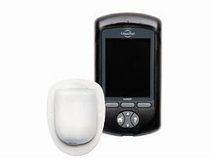
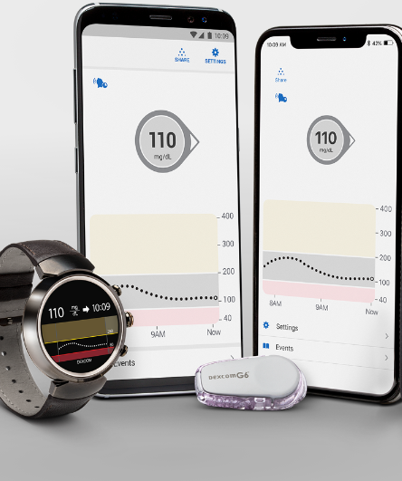

Animas Ping 1-877-937-7867

Accucheck: 1-800-688-4578

Medtronic Paradigm or Veo: 1-800-646-4633 or 1-800-minmed

Omnipod: 1-855-763-4636

